Session 10: Software Metrics & Complexity Analysis
Municipal Complaint Management System (MCMS) — Metrics Calculation Report
Prepared by –
Name | Roll Number
Aastha Sheoran | 2400290120004
Ananya Rajput | 2400290120042
Aashi Chaudhary | 2400290120003
Aeishikka Tyagi | 2400290120023
Repository: https://github.com/ananya489/SDLC-Municipal-Complaint-System

1. Scope and Basis of Measurement
Implementation has not started: the repository code folder holds only placeholder files. Metrics are therefore computed from the SRS and the Session 9 design. Each figure below is marked Measured or Estimated.
Artifact | Used for | Status
code/main.py, test/url.py | Size (LOC) | Measured: 1 line each (print statements only)
SRS v1.0 (FR-01 to FR-53 numbering) | Function points | Counted from the SRS requirements
assignComplaint() from AssignmentService (Session 9) | Halstead, cyclomatic, CFG | Pseudocode written for this report; representative module
SRS Fig D.2 decision tree; activity diagram | Workflow cyclomatic complexity | Counted from the diagrams

2. Size-Oriented Metrics
Metric | Value | Basis
Actual code size today | 2 LOC | Measured (placeholder code)
Adjusted function points | 264.9 FP | Section 3
Assumed language ratio | 47 LOC / FP | Assumed backfiring ratio for JavaScript
Estimated size at completion | 12,449 LOC (12.4 KLOC) | Estimated: 264.87 × 47
Specification size | 87 requirement statements | 53 FR + 5 AI-FR + 17 NFR + 12 BR in the SRS
Documentation density | 1.45 pages / KLOC | Estimated: 18 SRS pages ÷ 12.4 KLOC
Formulas to apply once code exists (inputs come from the repository and issue tracker):
Metric | Formula | Source of input
Productivity | KLOC ÷ person-months | Commit history, team log
Quality | Defects ÷ KLOC | GitHub Issues, test reports
Cost | Total cost ÷ LOC | Not applicable to the academic prototype
Documentation | Pages ÷ KLOC | Docs folder, cloc

3. Function Point Analysis
Method: IFPUG-style count. Complexity (Low / Average / High) is judged from the number of data fields and entities each function touches. Weights: EI 3/4/6, EO 4/5/7, EQ 3/4/6, ILF 7/10/15, EIF 5/7/10.

3.1 Internal Logical Files (ILF) — 10
# | File (collection) | Key data | Complexity | FP
1 | Complaints | ID, title, description, category, location, status, priority, deadline, timestamps | High | 15
2 | Users | Name, email, phone, address, password hash, role | Average | 10
3 | Assignments | Complaint, worker, department, officer, date, priority, deadline | Average | 10
4 | Departments | ID, name, description | Low | 7
5 | Categories | ID, name, description (holds SLA/deadline rule) | Low | 7
6 | FieldWorkers | ID, name, phone, department | Low | 7
7 | Evidence | ID, complaint, file URL, type, uploader, date | Low | 7
8 | StatusHistory | Old status, new status, actor, timestamp | Low | 7
9 | Notifications | ID, user, complaint, message, type, time | Low | 7
10 | Feedback | ID, complaint, citizen, rating, comment, date | Low | 7

3.2 External Interface Files (EIF) — 2
# | File | Why EIF | Complexity | FP
1 | Map service (Leaflet / OpenStreetMap) | Location data read, not maintained by MCMS | Low | 5
2 | AI service / model | Category, priority and similarity results read from outside MCMS | Low | 5

3.3 External Inputs (EI) — 21
# | Elementary process | SRS reference | Complexity | FP
1 | Register citizen | FR-01 | Average | 4
2 | Login | FR-02 | Low | 3
3 | Submit complaint (+ ID generation) | FR-07, 08, 12, 13 | High | 6
4 | Upload citizen evidence | FR-10, 11 | Average | 4
5 | Verify / reject complaint | FR-15, 16 | Average | 4
6 | Modify category / priority | FR-17 | Low | 3
7 | Assign department | FR-18 | Low | 3
8 | Assign field worker | FR-19, 20 | High | 6
9 | Update work progress | FR-29 | Average | 4
10 | Upload resolution evidence | FR-30, 31 | Average | 4
11 | Mark work completed | FR-32 | Low | 3
12 | Approve / reject resolution | FR-33, 34 | Average | 4
13 | Request reopening | FR-40 | Low | 3
14 | Submit rating and feedback | FR-38, 39 | Low | 3
15 | Escalate overdue complaint | FR-26 | Low | 3
16 | Update profile | Class diagram | Low | 3
17 | Manage users / officers / workers | FR-48 | Average | 4
18 | Manage departments | FR-49 | Average | 4
19 | Manage categories | FR-50 | Average | 4
20 | Manage staff-department assignment | FR-51 | Average | 4
21 | Manage deadline rules | FR-52 | Average | 4

3.4 External Outputs (EO) — 8
# | Elementary process | SRS reference | Complexity | FP
1 | Citizen dashboard | FR-43 | Low | 4
2 | Officer dashboard (counts) | FR-44 | Average | 5
3 | Worker dashboard | FR-45 | Low | 4
4 | Administrator statistics | FR-46 | Average | 5
5 | Reports (9 report types) | FR-47 | High | 7
6 | Notification generation | FR-35, 36 | Low | 4
7 | Overdue detection output | FR-24, 25 | Average | 5
8 | AI suggestions (category, priority, duplicates) | AI-FR-01 to 03 | Average | 5

3.5 External Inquiries (EQ) — 9
# | Elementary process | SRS reference | Complexity | FP
1 | View my complaints | FR-22 | Low | 3
2 | View complaint details + status timeline | FR-22, 23 | Average | 4
3 | Search by complaint ID | FR-41 | Low | 3
4 | Filter complaints (7 criteria) | FR-42 | Average | 4
5 | Officer views complaint queue / details | FR-14 | Average | 4
6 | Worker views assigned list | FR-27 | Low | 3
7 | Worker views complaint details | FR-28 | Low | 3
8 | View notifications | FR-37 | Low | 3
9 | Lookup categories / departments | FR-09, 49 | Low | 3

3.6 Unadjusted Function Points
Type | Low | Average | High | Subtotal
EI | 8 × 3 | 11 × 4 | 2 × 6 | 80
EO | 3 × 4 | 4 × 5 | 1 × 7 | 39
EQ | 6 × 3 | 3 × 4 | 0 × 6 | 30
ILF | 7 × 7 | 2 × 10 | 1 × 15 | 84
EIF | 2 × 5 | 0 × 7 | 0 × 10 | 10
Total UFP |  |  |  | 243

3.7 Value Adjustment Factor
Each of the 14 general system characteristics is rated 0 (no influence) to 5 (strong influence), by team judgement from the SRS.
# | Characteristic | Rating
1 | Data communications | 5
2 | Distributed data processing | 3
3 | Performance | 3
4 | Heavily used configuration | 2
5 | Transaction rate | 3
6 | Online data entry | 5
7 | End-user efficiency | 4
8 | Online update | 4
9 | Complex processing | 3
10 | Reusability | 2
11 | Installation ease | 2
12 | Operational ease | 3
13 | Multiple sites | 2
14 | Facilitate change | 3

Calculation | Result
Total Degree of Influence (TDI) | 44
VAF = 0.65 + 0.01 × TDI | 1.09
FP = UFP × VAF | 243 × 1.09 = 264.87
Adjusted function points | 264.9 FP

4. Halstead Metrics
Module measured: AssignmentService.assignComplaint() from Session 9 (validates the complaint and worker, saves the Assignment, updates status, writes history, notifies). The pseudocode is written in JavaScript to match the proposed Node.js stack.
async function assignComplaint(complaintId, workerId, officerId, deadline, priority) {
const complaint = await complaintRepo.findById(complaintId);
if (!complaint) {
throw new Error("NOT_FOUND");
}
if (complaint.status !== "Verified" && complaint.status !== "Reopened") {
throw new Error("INVALID_STATE");
}
const worker = await workerRepo.findById(workerId);
if (!worker || worker.departmentId !== complaint.departmentId) {
throw new Error("INVALID_WORKER");
}
if (deadline <= Date.now()) {
throw new Error("INVALID_DEADLINE");
}
const assignment = await assignmentRepo.create(complaintId, workerId, officerId, deadline, priority);
await complaintRepo.updateStatus(complaintId, "Assigned");
await statusHistoryRepo.record(complaintId, complaint.status, "Assigned", officerId);
notificationService.send(workerId, "ComplaintAssigned", complaintId);
return assignment;
}
Counting rules
- Operators: keywords, assignment/comparison/logical symbols, member access ( . ), separators ( , ; ), and each paired () or {} counted once.
- Operands: identifiers (variables, parameters, function and property names) and literals. Each distinct spelling is one operand.

4.1 Operators (n1 = 19, N1 = 92)
Operator | Count | Operator | Count
() | 16 | = | 3
, | 14 | !== | 3
. | 12 | ! | 2
; | 11 | async | 1
await | 5 | function | 1
{} | 5 | && | 1
if | 4 | || | 1
throw | 4 | <= | 1
new | 4 | return | 1
const | 3

4.2 Operands (n2 = 32, N2 = 62)
complaintId (6), complaint (6), workerId (4), Error (4), officerId (3), deadline (3), status (3), worker (3), priority (2), complaintRepo (2), findById (2), departmentId (2), assignment (2), Assigned (2), assignComplaint (1), NOT_FOUND (1), Verified (1), Reopened (1), INVALID_STATE (1), workerRepo (1), INVALID_WORKER (1), Date (1), now (1), INVALID_DEADLINE (1), assignmentRepo (1), create (1), updateStatus (1), statusHistoryRepo (1), record (1), notificationService (1), send (1), ComplaintAssigned (1).

4.3 Results
Measure | Formula | Value
Vocabulary n | n1 + n2 | 19 + 32 = 51
Length N | N1 + N2 | 92 + 62 = 154
Estimated length N^ | n1·log2(n1) + n2·log2(n2) | 240.7
Volume V | N × log2(n) | 873.6
Difficulty D | (n1 / 2) × (N2 / n2) | 18.41
Effort E | D × V | 16,079
Time T | E / 18 seconds | 893 s (≈ 14.9 min)
Delivered bugs B | V / 3000 | 0.29
Reading: V = 874 is a small, easily reviewed function; D = 18.4 comes mainly from many distinct repository calls and error literals. The estimated length N^ is higher than the actual N because the formula assumes a larger program. Treat B as a rough indicator only.

5. Cyclomatic Complexity and Control Flow Graph

5.1 Control Flow Graph of assignComplaint()
Compound conditions are split so each simple predicate is its own node (node 4 and 5 form the && check; node 8 and 9 form the || check). Node 13 groups the straight-line success statements.
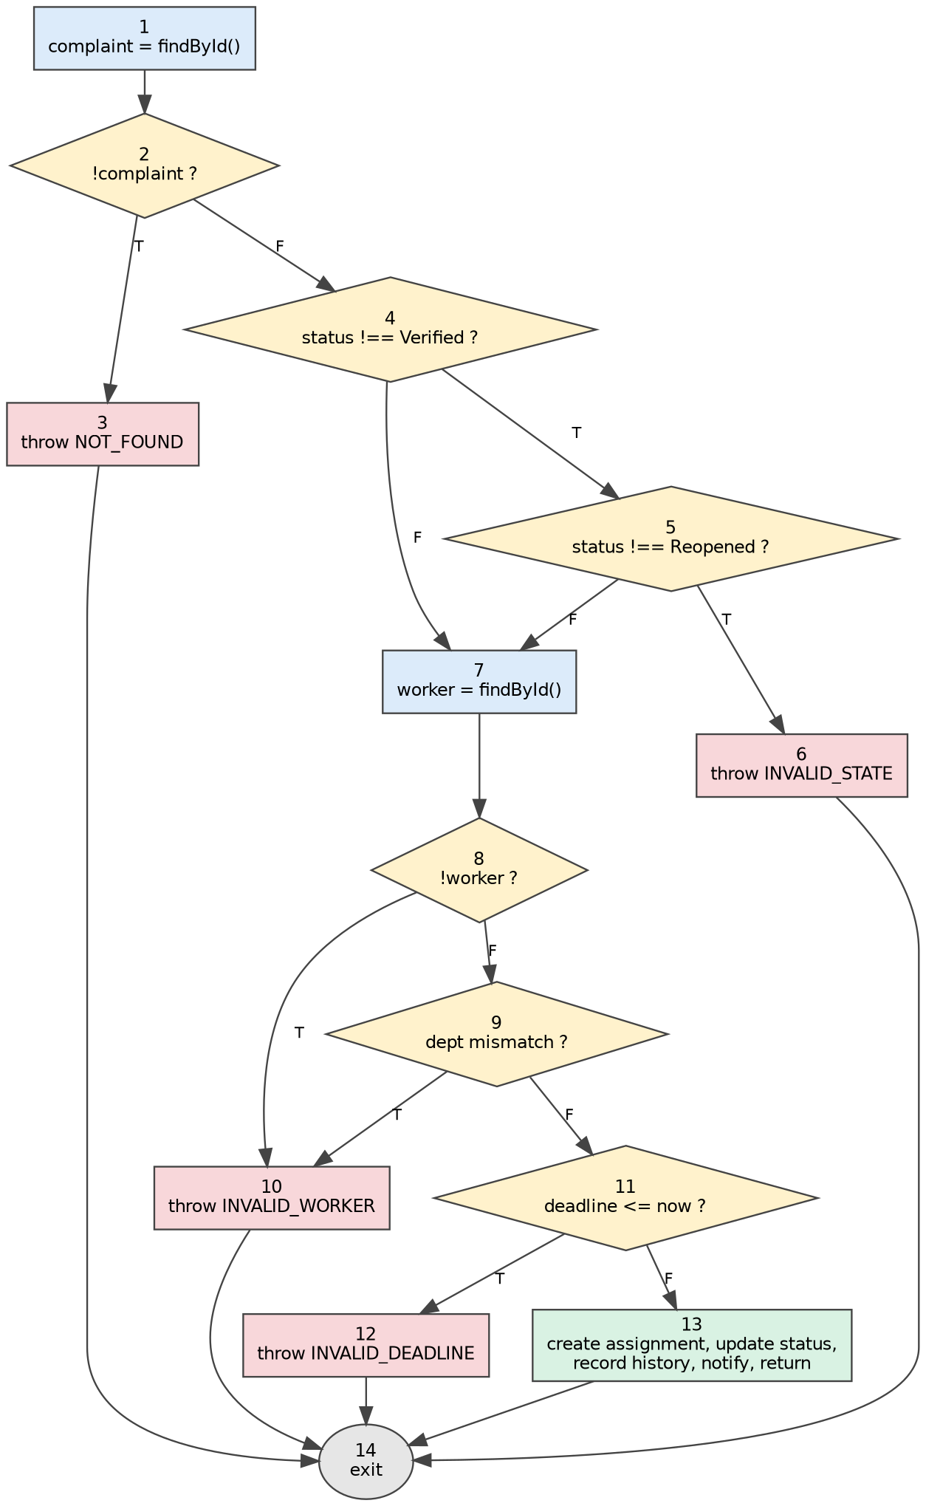

5.2 Calculation
Method | Working | V(G)
Edges − nodes + 2 | 19 − 14 + 2 | 7
Predicate nodes + 1 | 6 predicates (nodes 2, 4, 5, 8, 9, 11) + 1 | 7
Number of regions | 7 enclosed/outer regions in the CFG | 7

5.3 Basis (independent) paths
V(G) = 7 means 7 linearly independent paths, so at least 7 test cases are needed for full basis-path coverage. The path vectors were checked numerically and have rank 7.
# | Path (nodes) | Test scenario
P1 | 1-2-3-14 | Complaint ID does not exist
P2 | 1-2-4-5-6-14 | Status is neither Verified nor Reopened
P3 | 1-2-4-7-8-10-14 | Verified complaint, worker not found
P4 | 1-2-4-7-8-9-10-14 | Verified complaint, worker from another department
P5 | 1-2-4-5-7-8-9-11-12-14 | Reopened complaint, valid worker, deadline in the past
P6 | 1-2-4-7-8-9-11-13-14 | Verified complaint, valid inputs (success)
P7 | 1-2-4-5-7-8-9-11-13-14 | Reopened complaint, valid inputs (success)

5.4 Complexity of the workflow models
Model | Decision nodes | Count | V(G)
assignComplaint() (code level) | Section 5.2 | 6 | 7
Decision tree (SRS Fig D.2) | Authenticated? Valid and complete? Emergency? Resolved? Resolution approved? | 5 | 6
Activity diagram (Requirements Report) | Valid? Deadline exceeded? Resolved? | 3 | 4
Risk bands (SEI): 1–10 simple, low risk; 11–20 moderate; 21–50 complex, high risk; above 50 untestable. All three models are in the low-risk band.
Observation: the decision tree has an emergency-routing branch (Emergency Response Team) that no FR in the SRS defines, while NFR-05 says MCMS is not a substitute for emergency services. Resolve this before implementation, since it adds a branch and a required test.

6. Industry Mapping: Software Quality Measurement
Metric | How industry uses it | Applying it to MCMS
LOC / KLOC | Size tracking, defect density, productivity benchmarks (cloc and similar tools). | Run cloc on each release; compare with the 12.4 KLOC estimate.
Function points | Technology-independent sizing for estimates and contracts (IFPUG standard). | Re-count after design changes; track FP growth as scope changes.
Halstead | Input to the Maintainability Index; flags dense, hard-to-read code. | Measure modules with a JavaScript analyzer (for example Plato / escomplex).
Cyclomatic complexity | Quality gates in CI (ESLint complexity rule, SonarQube); sets minimum test count. | Add a CI check on GitHub Actions: fail a pull request if any function exceeds V(G) = 10.
ISO/IEC 25010 | Quality model: maintainability (modularity, analysability, testability) is what these metrics indicate. | Supports NFR maintainability and the testability attribute in SRS Section 5.4.

7. Summary of Results
Metric | Result | Status
Actual LOC in repository | 2 | Measured
Unadjusted function points | 243 | Estimated
Value adjustment factor | 1.09 | Estimated
Adjusted function points | 264.9 | Estimated
Estimated size | 12.4 KLOC | Estimated
Halstead volume / effort (assignComplaint) | 873.6 / 16,079 | Design-level
Cyclomatic complexity (assignComplaint) | 7 | Design-level
Cyclomatic complexity (decision tree / activity diagram) | 6 / 4 | Counted from diagrams
Limitations: the 47 LOC/FP ratio is an assumption; GSC ratings and EI/EO/EQ complexity levels are judgement calls; Halstead and V(G) cover one representative function. Re-measure on the real code after implementation and replace the estimates.

